**ACTIVITY 1**

1. Open index.html on **Chrome**
2. Open the “**Elements**” tab of the developer’s tools (Ctrl + shift + I)

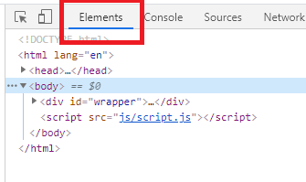

1. Answer following questions and **return your word documents on skype**:

Q1 – How many children has the element of id **add-book** ?

2 element input and button

Q2 – What is the **parent** of the element h2 “book to read”?

Id book list parent of h2” book to read”

Q3 – What are the ID and CLASS of element are used for?

The class is an attribute which specifies one or more class names for an HTML element.

The id global attribute defines an identifier (ID) which must be unique in the whole document.

Q4 – Select the <div> of id “book-list” and delete it. What happens?

When deleted <div> of id “book -list” we don’t see element in Brower.